Facebookopslag i 2022
For projektet Viden til økologiske landmænd
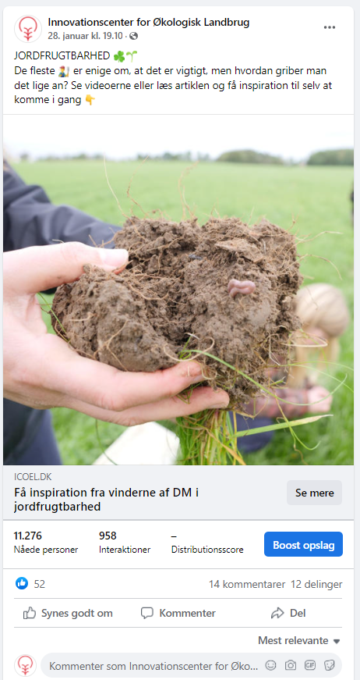
https://www.facebook.com/icoel.dk/posts/142067194906469

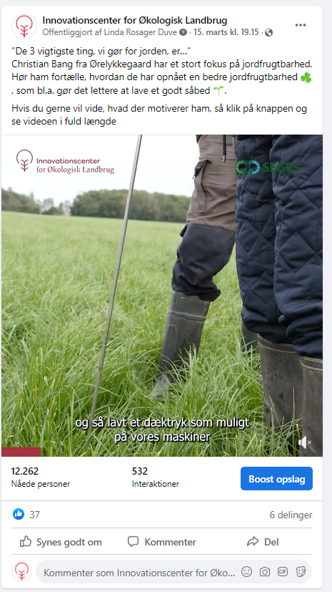
https://www.facebook.com/icoel.dk/posts/152855057161016
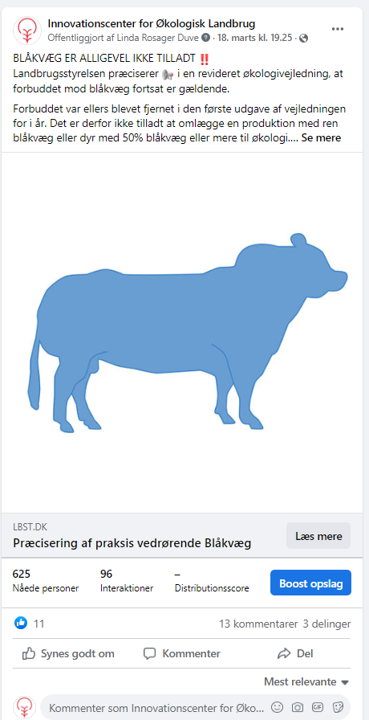
https://www.facebook.com/icoel.dk/posts/153527407093781
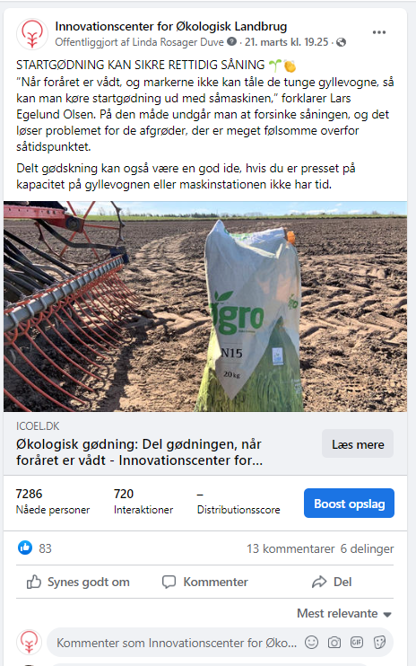
https://www.facebook.com/icoel.dk/posts/154139990365856

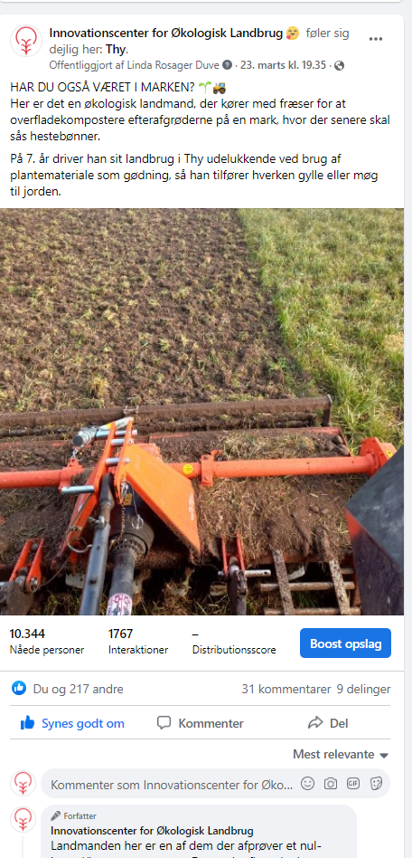
https://www.facebook.com/icoel.dk/posts/154372910342564

